**C.V**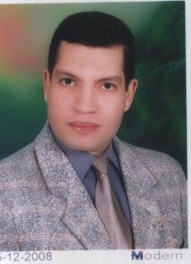

**Personal data**

**Name: Ayman Abdullah genedy**

**Telephone number: Mobile: 35088285**

**Address: Bahrain - Al Muharraq ((with a year and a Bahraini driving license))**

**Career Objective**

**I look forward to using the scientific knowledge gained during my course of study and using my practical and personal experiences**

**Ensuring efficient and efficient working quality**

**Qualifications : Bachelor of Agricultural Science with a good degree from Cairo University**

**Of experience**

**After that, I worked for a one year as a data entry ( stor keeper ) and goods receiver on the**

**B D T machine at the Ramez Group stores in Manama branch**

**Worked for seven months as an agricultural engineer responsible for the sale, treatment, fertilization and sales of orchard plant ornamental plants in Bahrain**

**Worked for six months telemarketing employee at Amwaj for water desalination plants in Tubli**

**Worked in charge of a shop selling vegetables and fruit Balbsitin**

**Experience of five years in administrative and secretarial work as Director of the Office of the Director General of Education from photocopying and use of computer in the work of writing and printing and confiscated, and to schedule and answer the telephone and hold meetings and the introduction of data on the computer and writing letters and respond to correspondence through the computer and the experience of social networking sites**

**Personal skills**

**Be diligent and committed to my work and keep appointments**

**Work under pressure**

**Ability to work in critical times such as vacations or operating system chefs**

**Obtaining a certificateI C D L International Computer Management License**

**Get Intel Teach program training**